CSYE 6225 Assignment 08 Jiading Zhou

**(Screenshot #1) Capture the VPC creation summary page showing the VPC ID,**

**name, and CIDR block.**

* VPC (webapp-vpc) with CIDR Block: 10.0.0.0/16

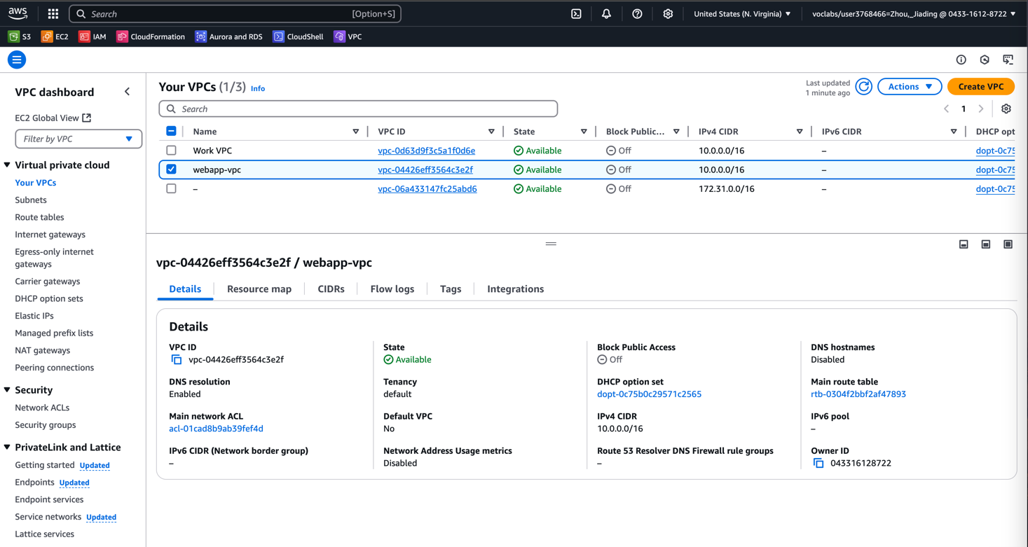

**(Screenshot #2) Capture subnet configurations, including CIDR blocks and**

**availability zones**

* VPC Resource Map with 5 subnets (3 public and 2 private)

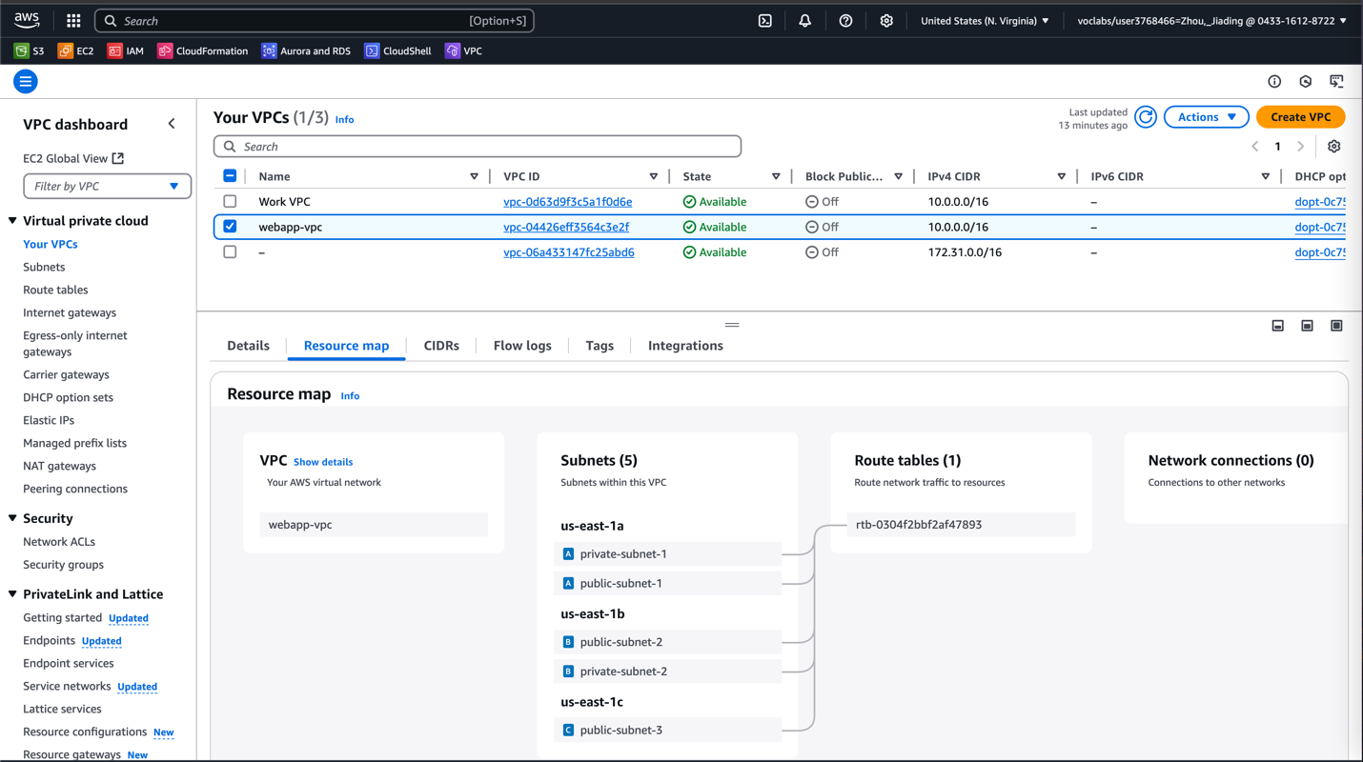

* Public subnet 1

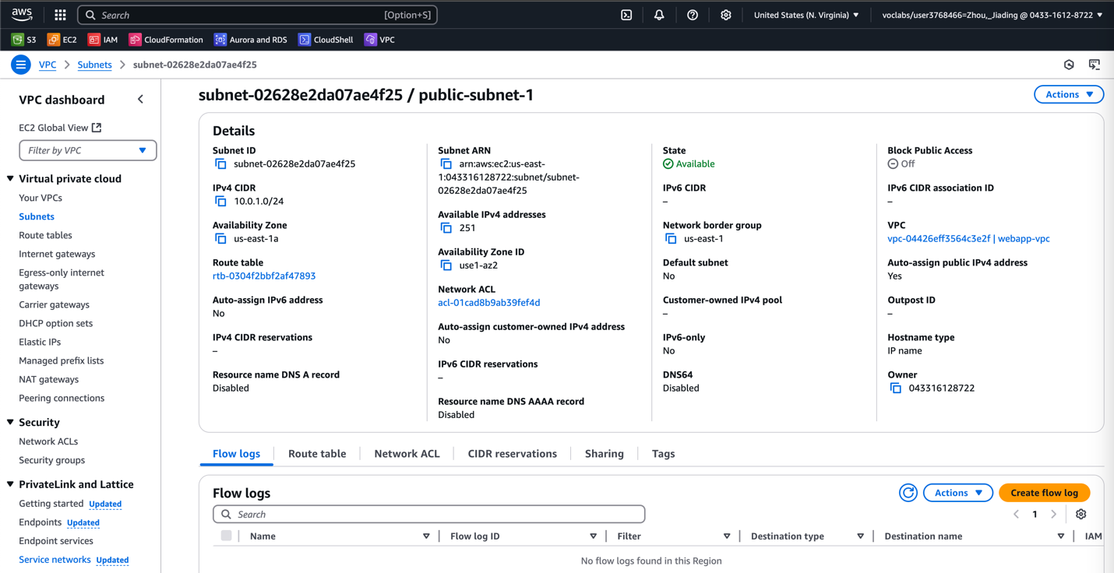

* Public subnet 2

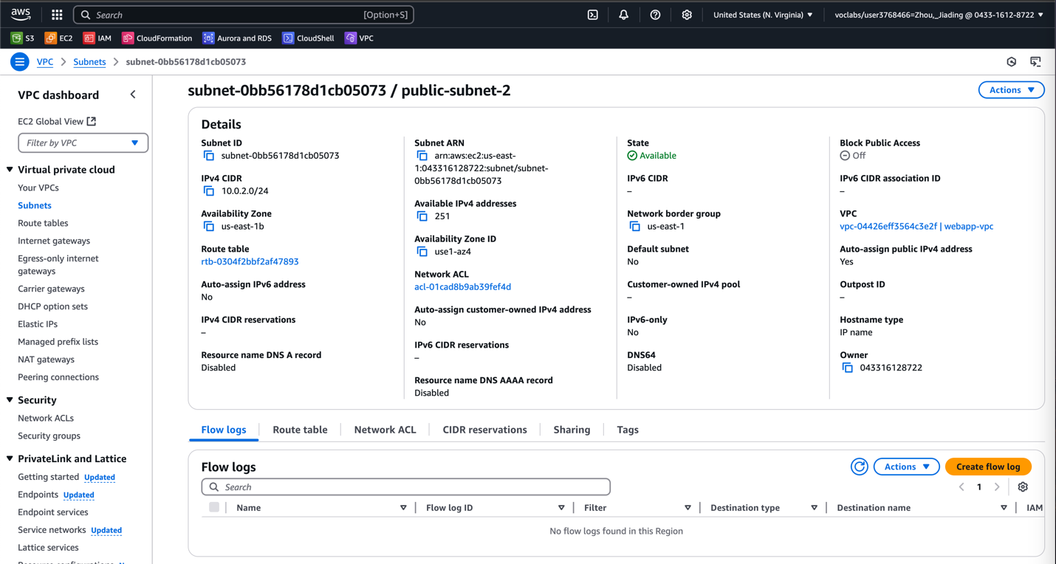

* Public subnet 3

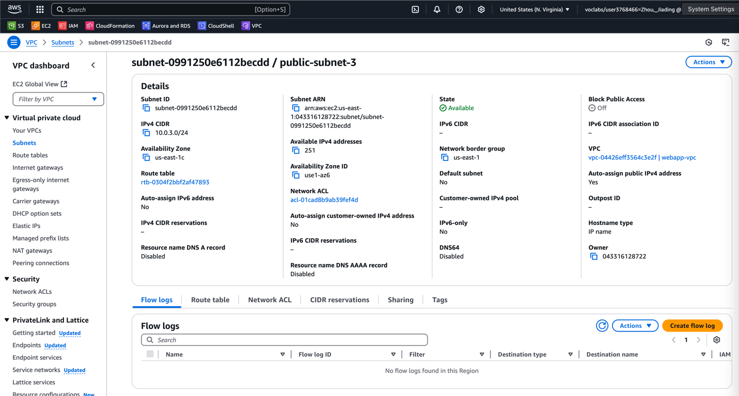

* Private subnet 1

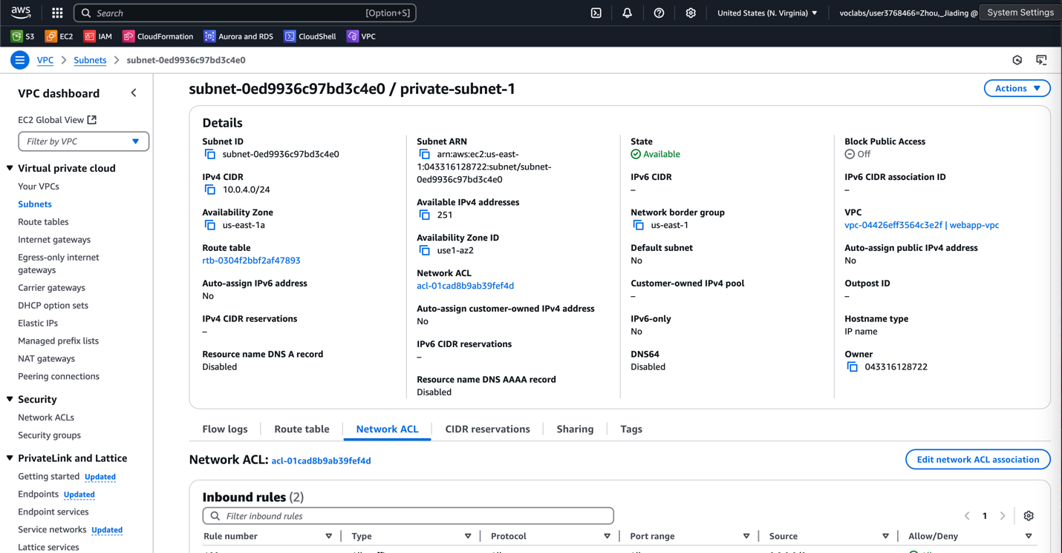

* Private subnet 2

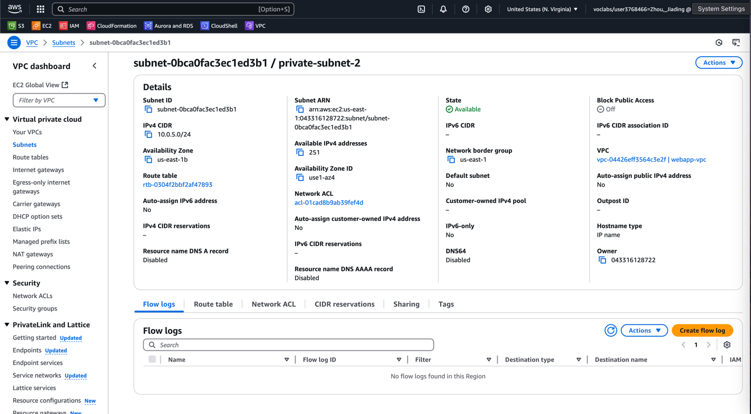

**(Screenshot #3) Show IGW attachment and route table configurations**

* Internet Gateway attached on the VPC (webapp-vpc)
* And webapp VPC resource map with Route tables and IGW attached

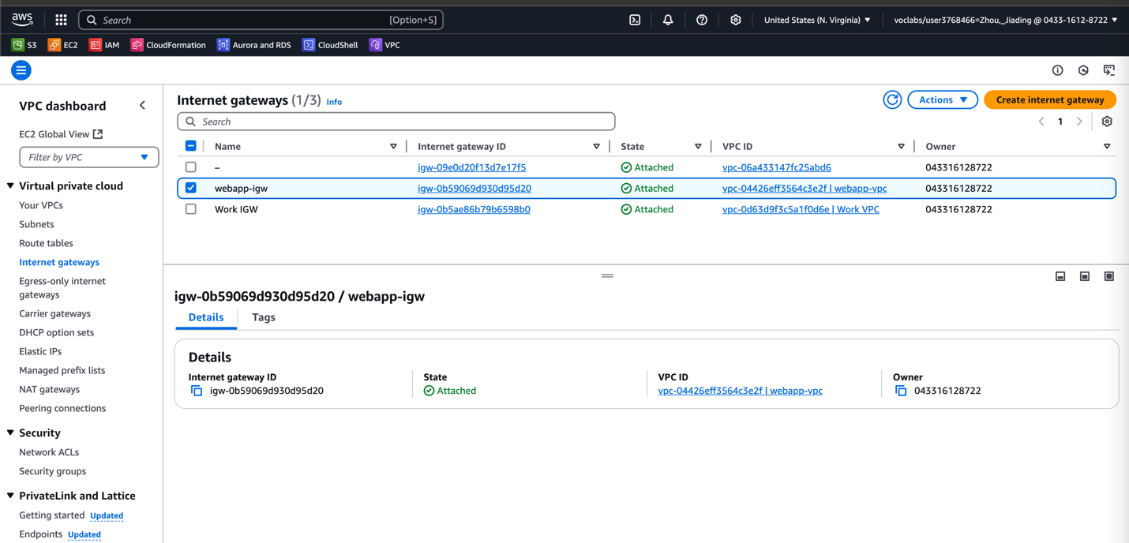

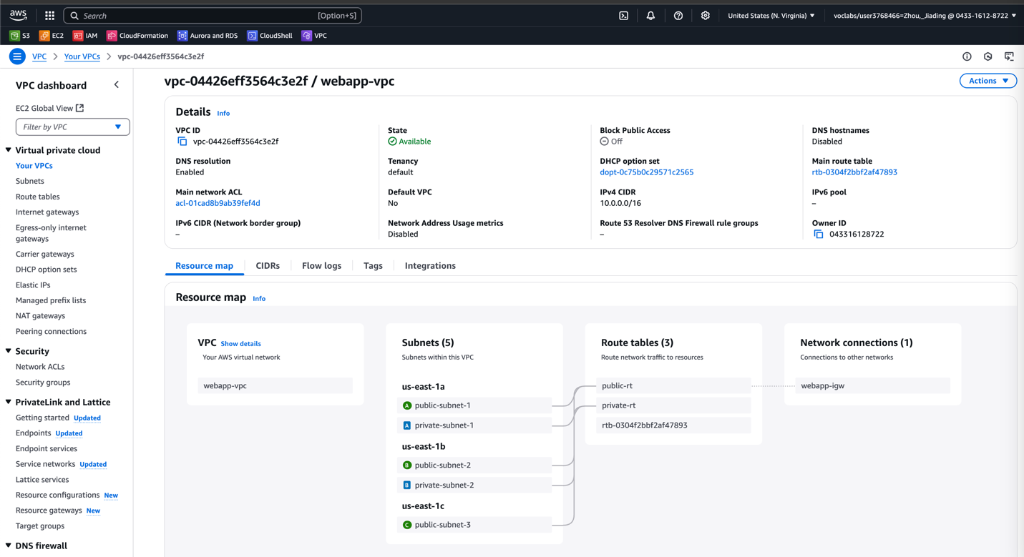

* Public route table

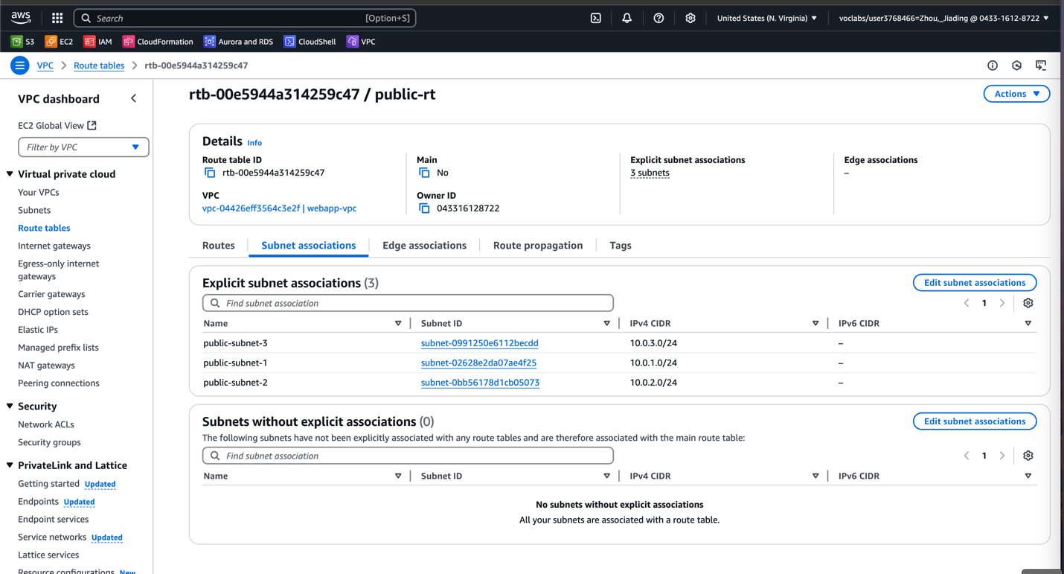

* Private route table

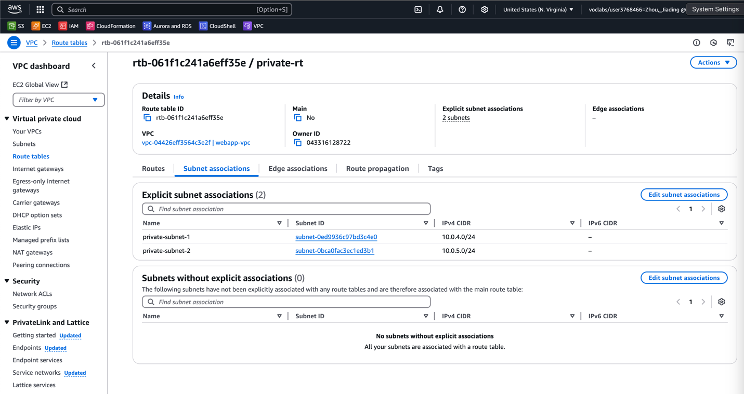

**(Screenshot #4) Capture ALB security group rules for both inbound and outbound traffic**

* Security Group for Application Load Balancer
* Inbound -> HTTP port 80, outbound -> anywhere

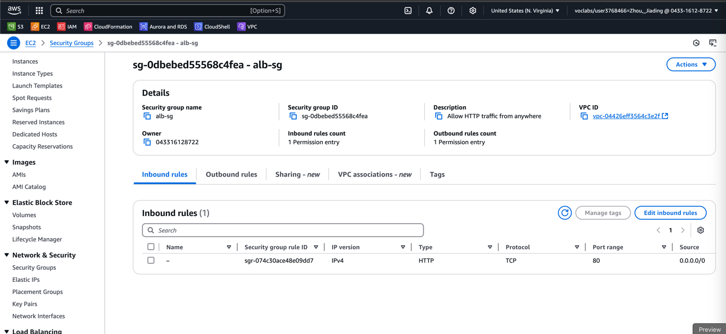

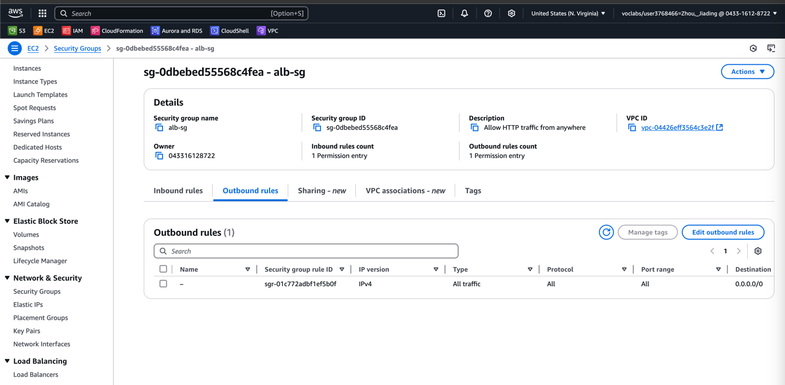

**(Screenshot #5) Show EC2 instances' security group settings (Screenshot #5)**

* Here is the security group for EC2, which allow inbound to port 8080 that only from the ALB security group

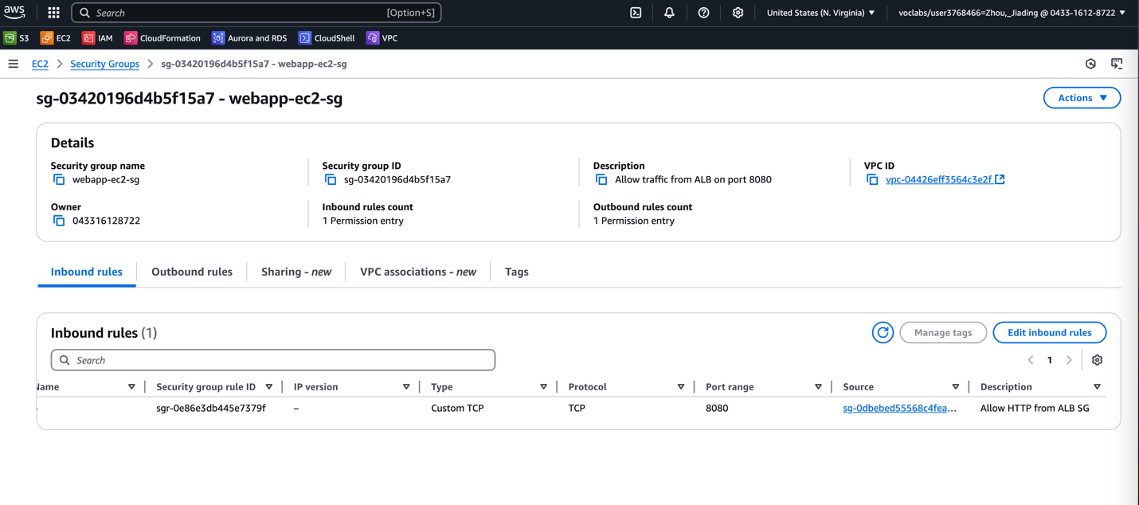

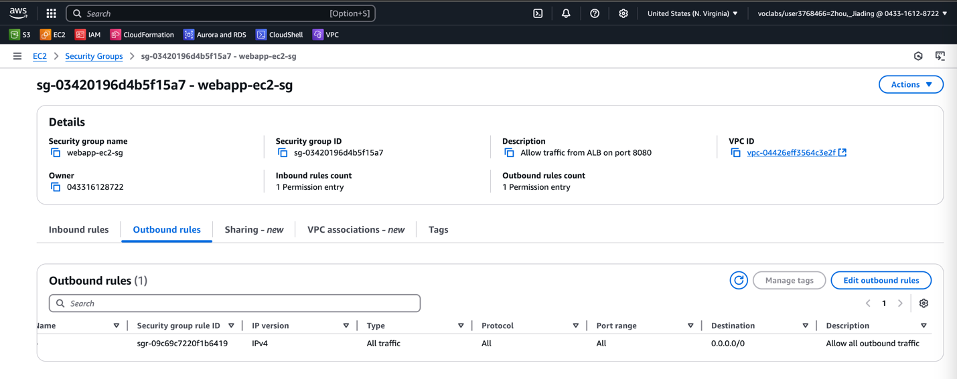

**(Screenshot #6) Show RDS security group settings**

* Inbound MySQL (port 3306) & PostgreSQL (port 5432)

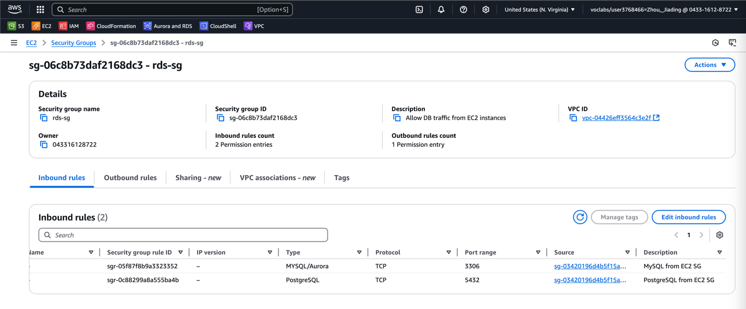

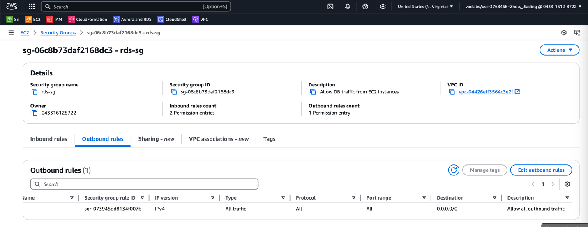

**(Screenshot #7) RDS instance configuration summary, showing instance class, engine,**

**and network settings**

* PostgreSQL with rds-sg

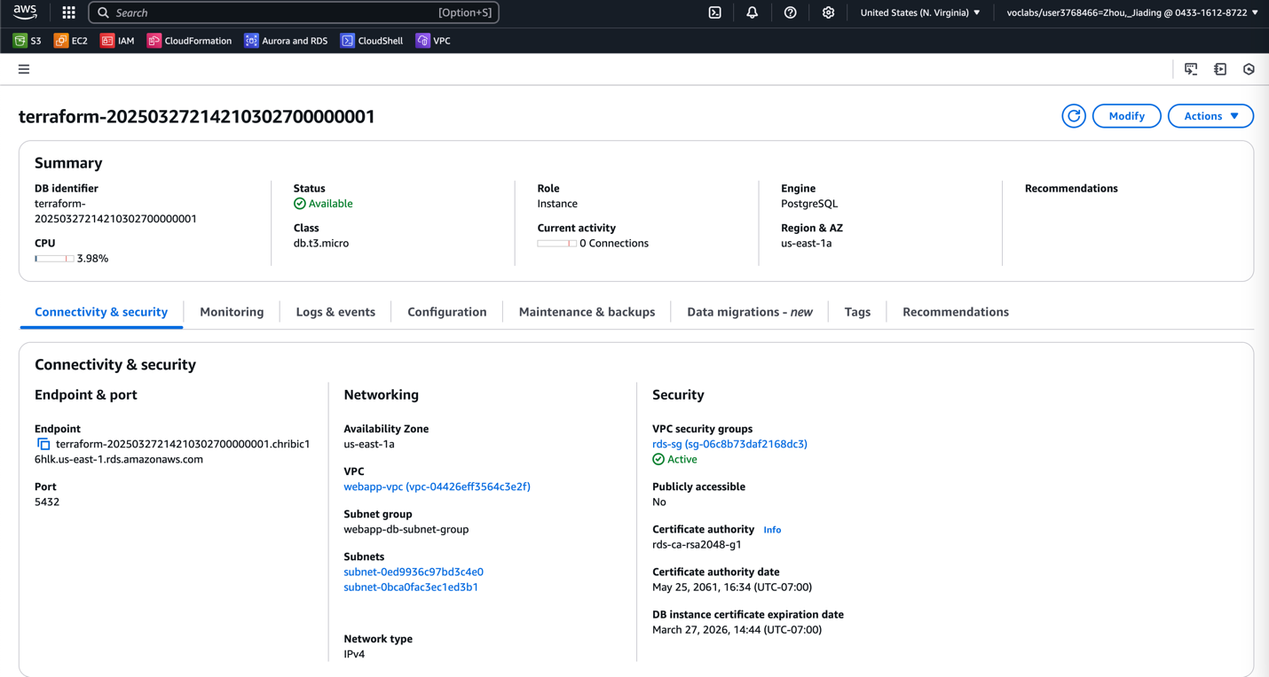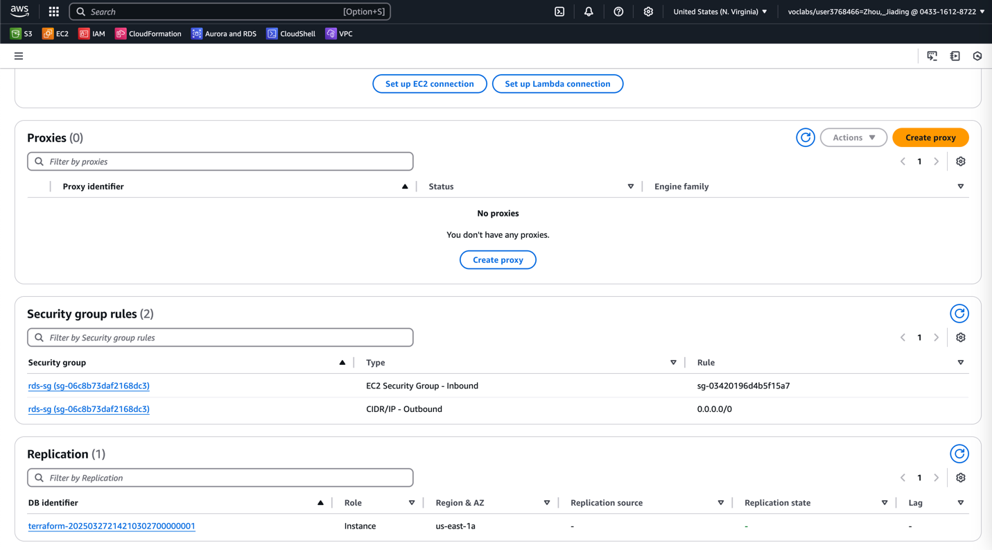

* PostgreSQL config with Master username (webAppDBAdmin)

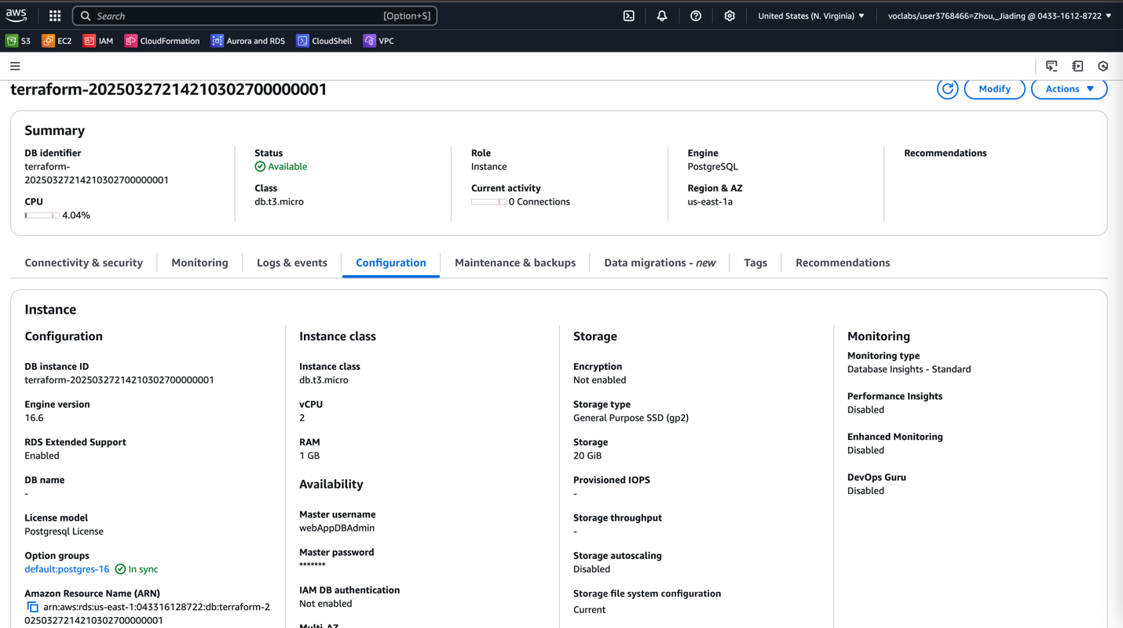

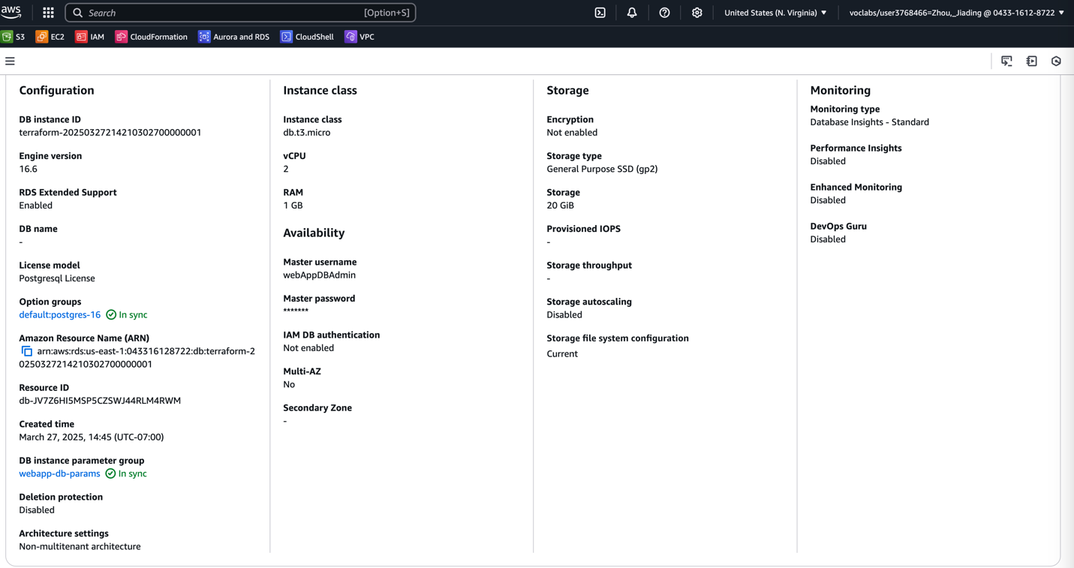

* also with DB instance parameter group to set the “rds.force_ssl” to 0 for RDS to accept connections from web app.

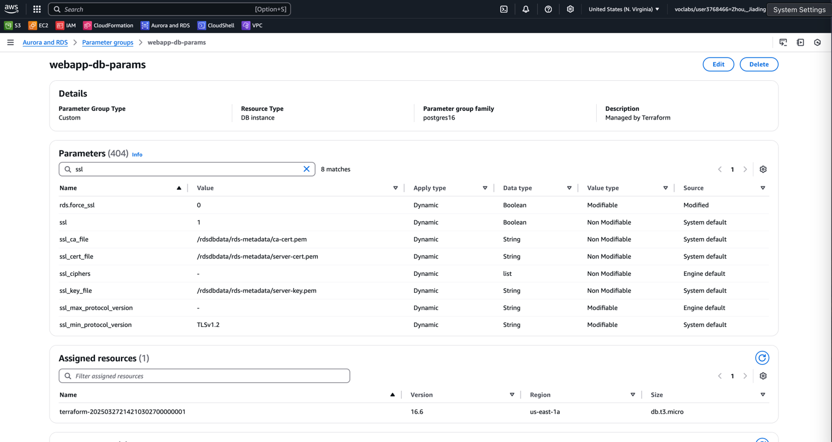

**(Screenshot #8) Launch Template configuration page, including the instance type and user data script**

* EC2 Launch Template

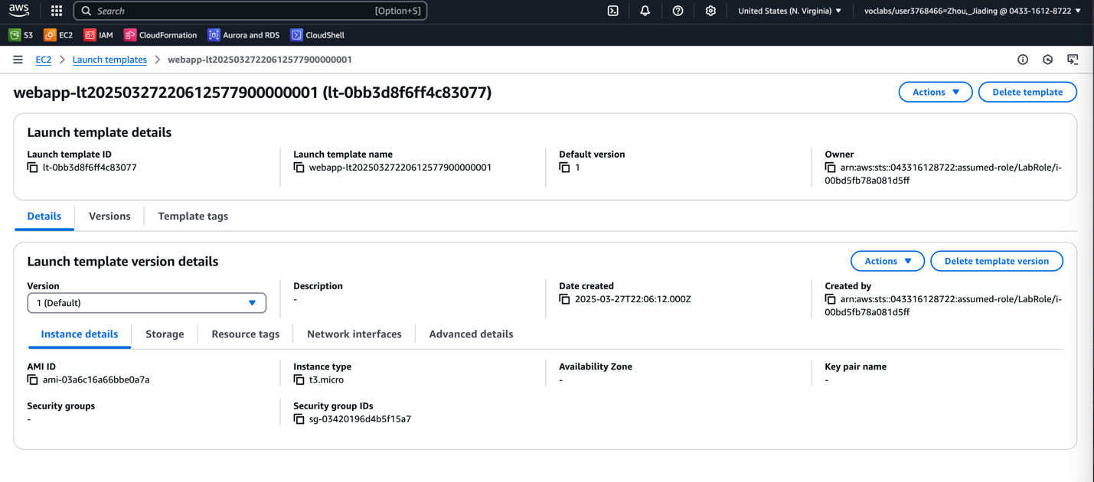

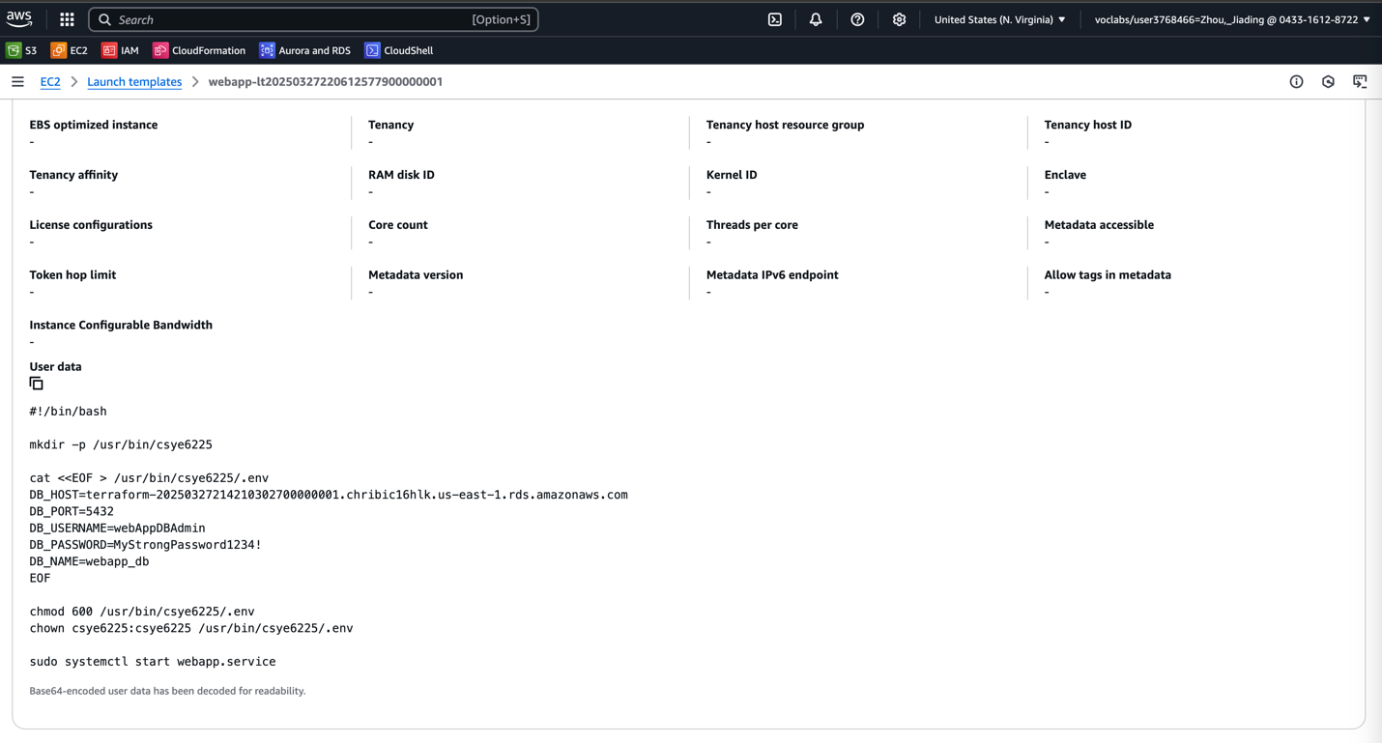

**(Screenshot #9) Target group settings, including health check configurations**

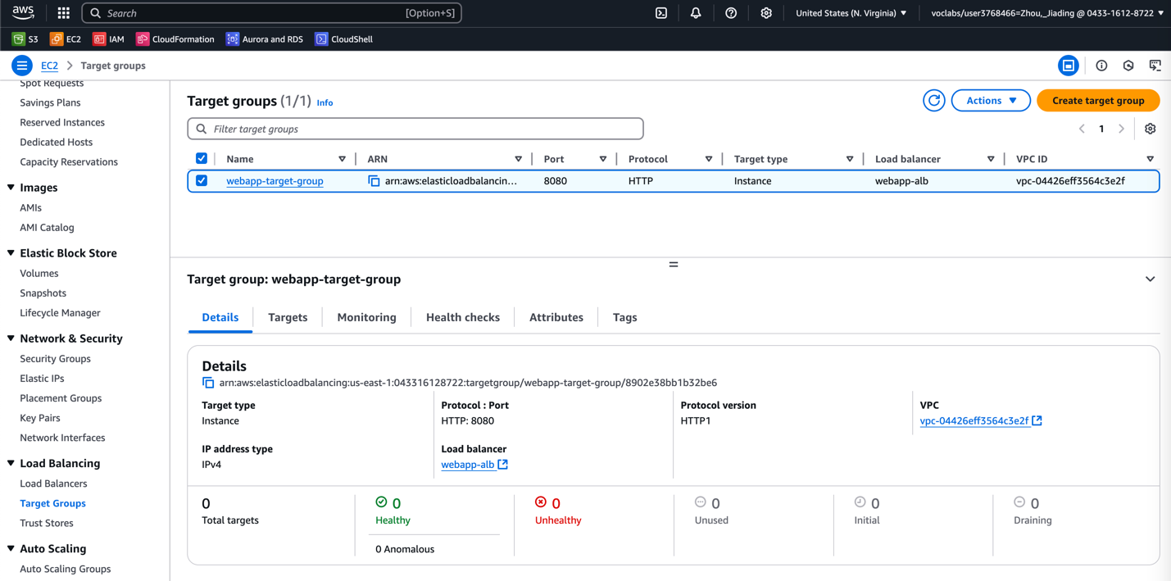

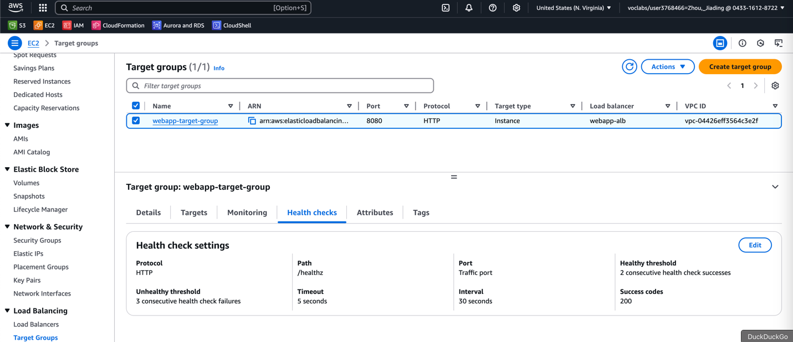

**(Screenshot #10) ASG settings, including instance counts**

* Auto Scaling Group

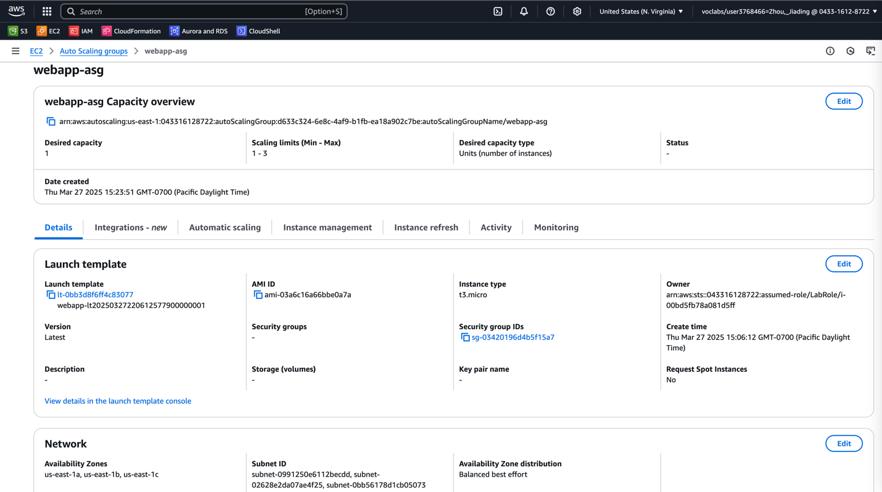

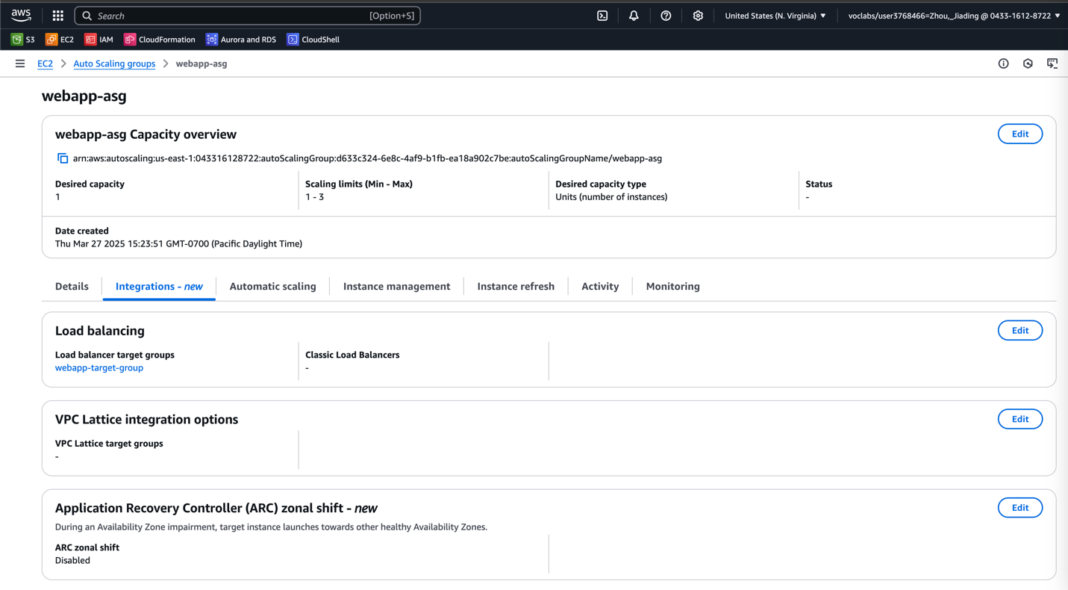

**(Screenshot #11) CloudWatch alarm configurations for scaling policies**

* CloudWatch alarm (CPU > 70% Scale Up) (CPU < 30% Scale Down)

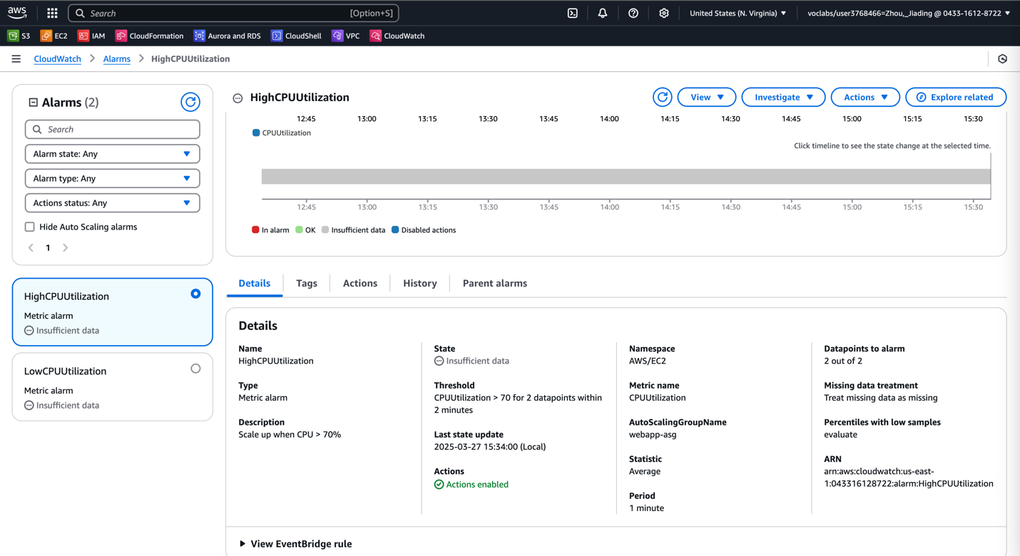

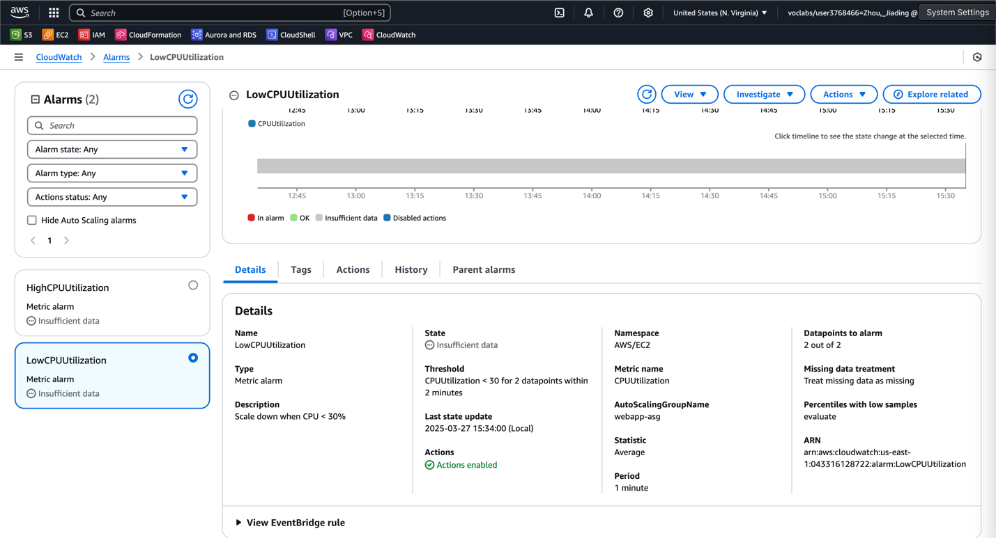

**(Screenshot #12) Scaling up and down of instances in the ASG during load testing**

* First, using wrk for Load Testing.
* Init try in 10 threads, 100 open connections, run for 5 min

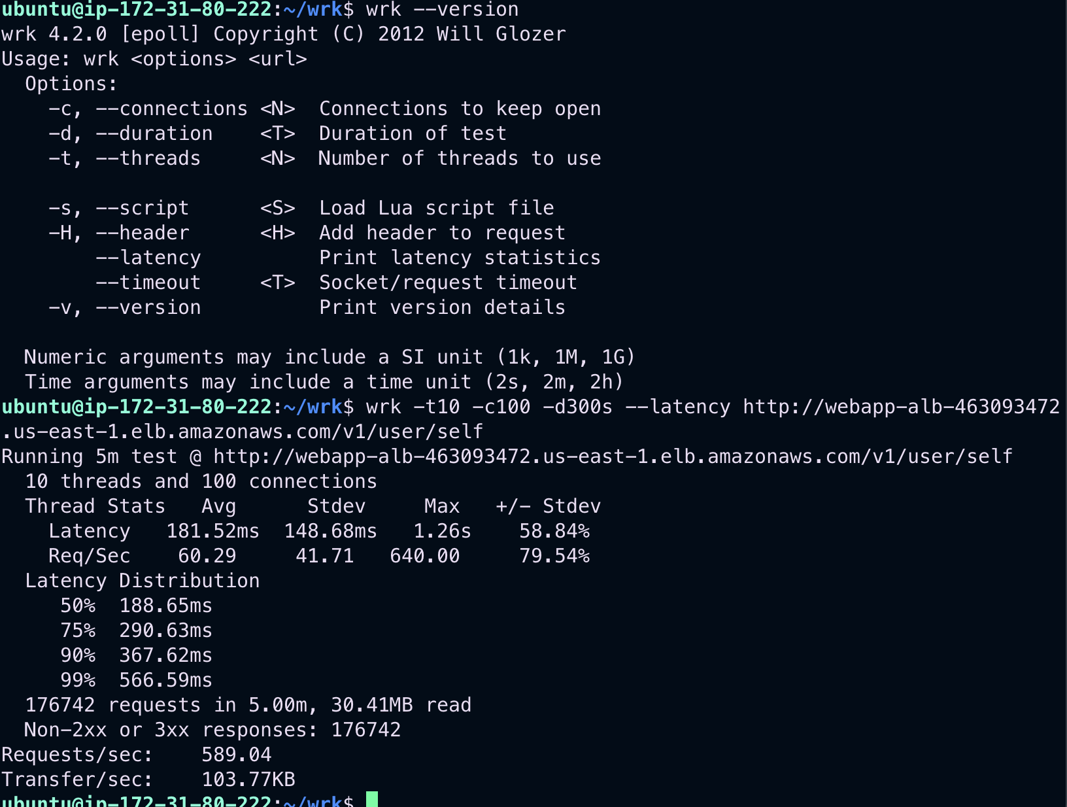

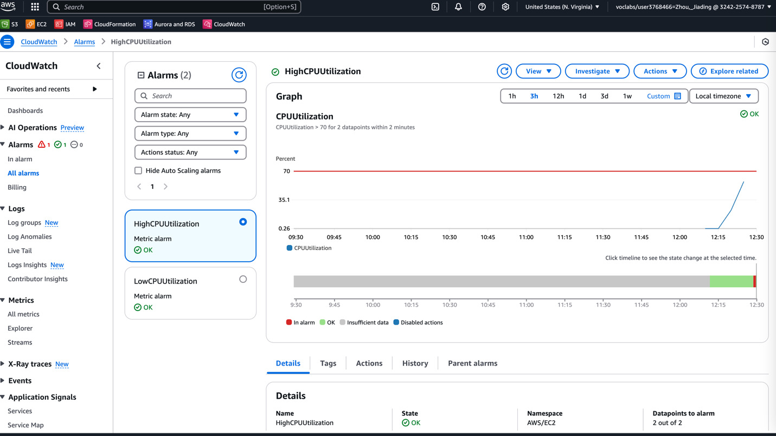

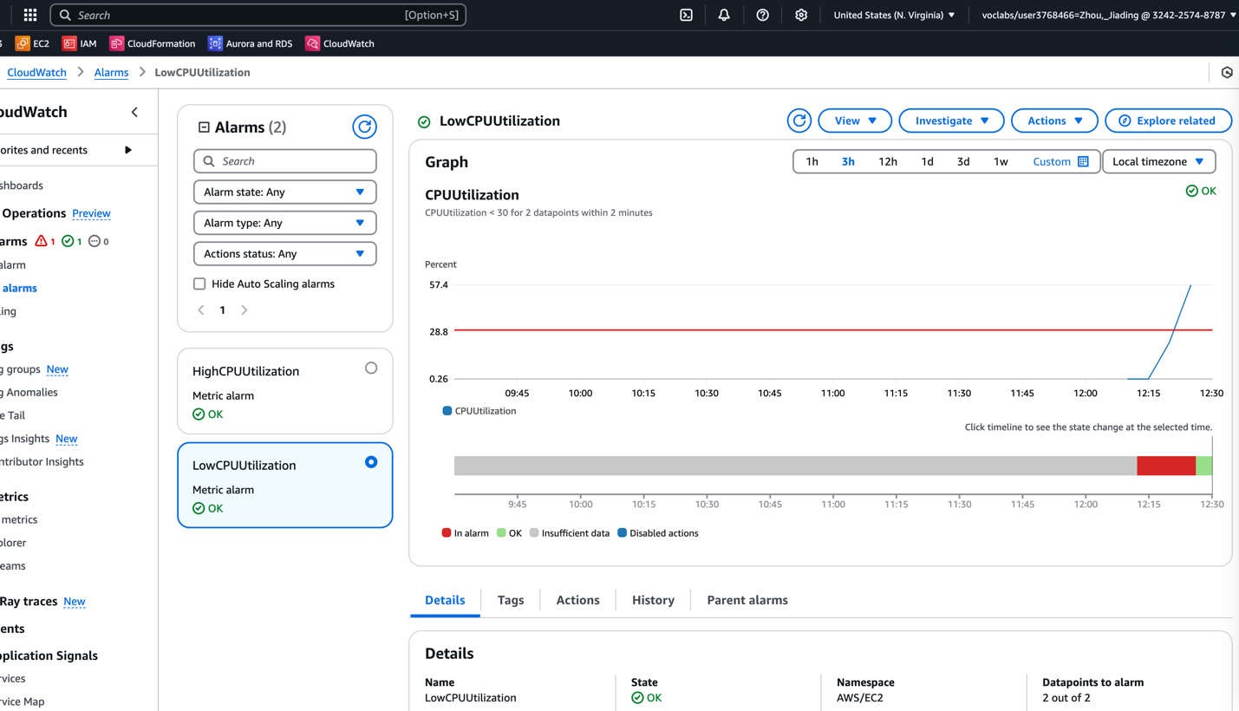

* Increase the load and try again
* try in 20 threads, 200 open connections, run for 10 min

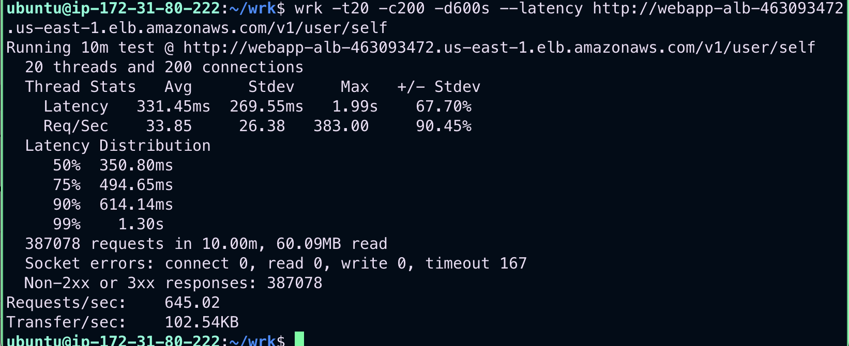

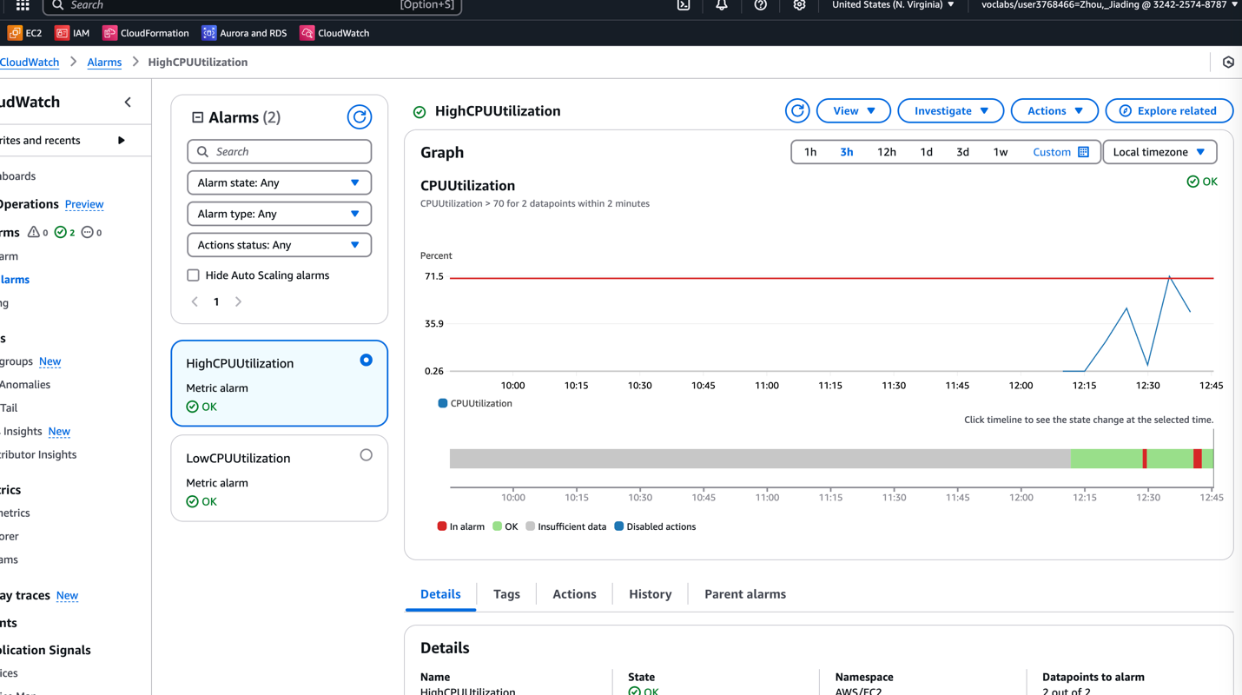

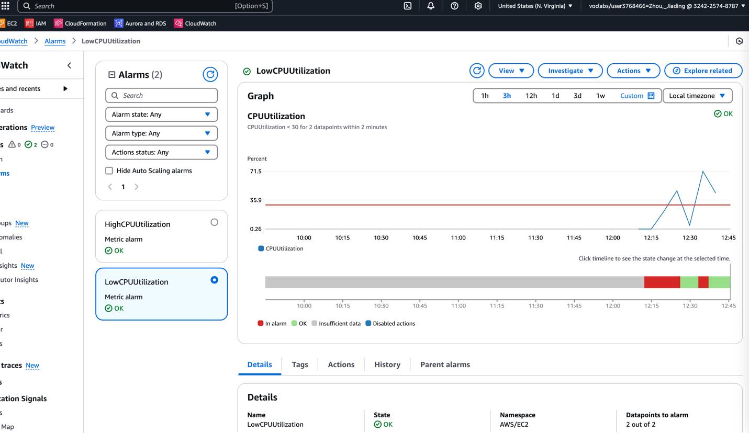

* looks good
* Load Balancer and Auto Scaling works
  + It detected the load over 70%, and auto launch the new instance
  + Then, CPU utilization decrease
  + After load reduced, it terminated the instance to run with less resource

**(Screenshot #13) Request and response for each API call**

**Use Postman**

GET - http:// webapp-alb-463093472.us-east-1.elb.amazonaws.com/healthz

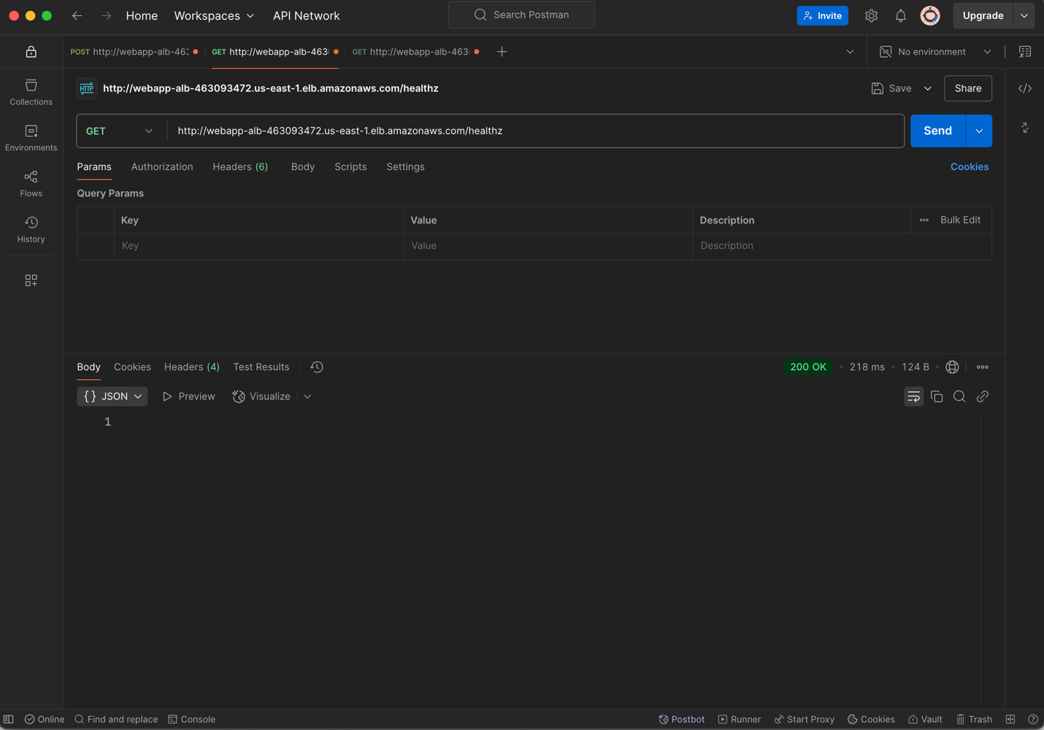

POSR - <http://webapp-alb-463093472.us-east-1.elb.amazonaws.com/v1/user>

{

"email": "testuser@example.com",

"password": "StrongPass123!",

"first_name": "Test",

"last_name": "User"

}

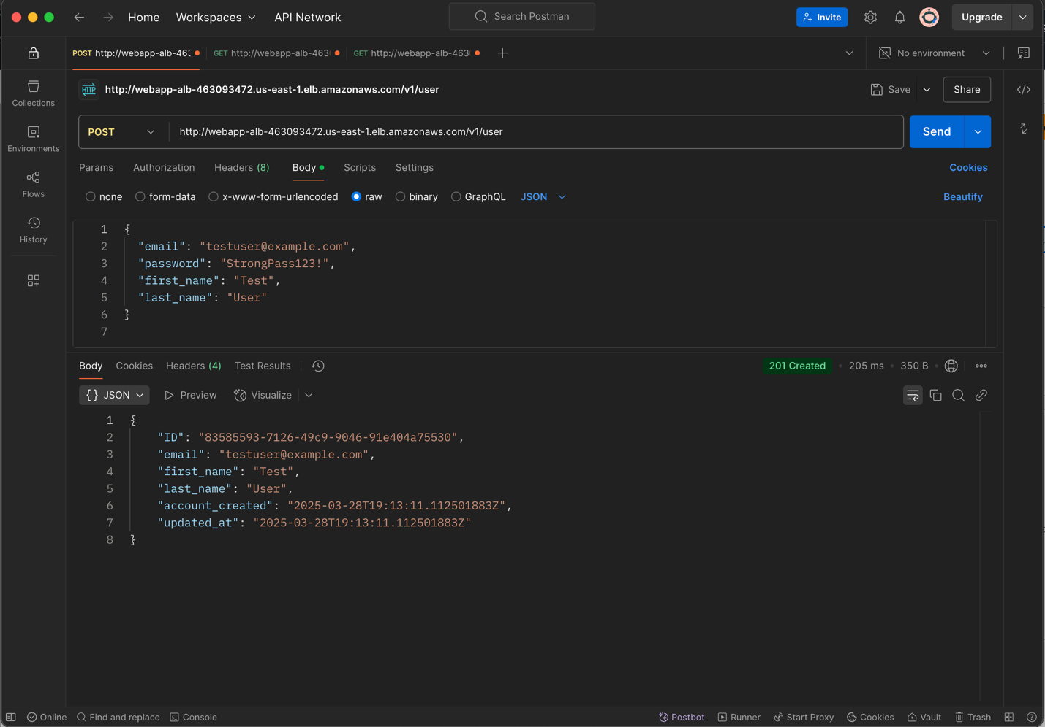

GET - <http://webapp-alb-463093472.us-east-1.elb.amazonaws.com/v1/user/self>

